Department | Mechanical Engineering in Polytechnic |  |  |  |  |  |  |  |  |  |  | 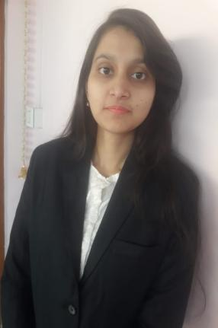
Designation: | Lecturer
Name of Faculty: | Ms. Bagwan Aasiya Nasir
Date of Birth: | 01/02/2001 |  | Date of Joining: |  |  | 30/09/2025
Qualification with Class/Grade | UG |  | PG |  |  | Ph.D.
Qualification with Class/Grade | First Class with Distinction in B.Tech in Mechanical Engineering |  | - |  |  | -
Area of Specialization: | Engineering Drawing
Total Experience in Years: | Teaching |  |  | Industry |  |  |  |  |  |  | Research
Total Experience in Years: | 1 |  |  | 00 |  |  |  |  |  |  | -
Mobile No: | 8625846871 |  |  | E-mail ID: |  |  |  |  |  | aasiyabagwan_engg@yes.edu.in
Number of PhD, M. Tech , B. Tech Project Guided | UG: -00 |  |  |  |  |  | PG: Nil |  |  |  |  | Ph.D. : Nil
Professional Society Memberships
Paper Published in Journals | National:00 |  |  |  |  |  |  | International: 00
Paper Presented in Conferences | National: 00 |  |  |  |  |  |  | International: 00
Books/Chapters/ Patents / Copy rights Published | Books: 00 |  | Chapters: 00 |  |  |  |  | Patents:- 00 |  |  |  | Copyrights: -00
STTPs, FDPs, Workshops attended | STTPs: 00 |  |  |  | FDPs: 4 |  |  |  |  |  | Workshops: 00
Webinars & Seminars attended | Webinars: 1 |  |  |  |  |  |  |  | Seminars: 00
STTP, FDP,Webinar& Seminar conducted | STTP: 00 | FDP: 00 |  |  |  |  |  | Seminar: 00 |  |  |  | Webinar: 00
Resource Person Work Details | -
NPTEL/Swayam/NITTR/MOOC/ Other courses | 2
Awards/Recognition | -
Consultancy | O -
Google Scholar Link | -
Google Site | -


Name & Signature of Faculty

