FACULTY-BIODATA
Department | Mechanical Engineering |  |  |  |  |  |  |  |  |  |  | 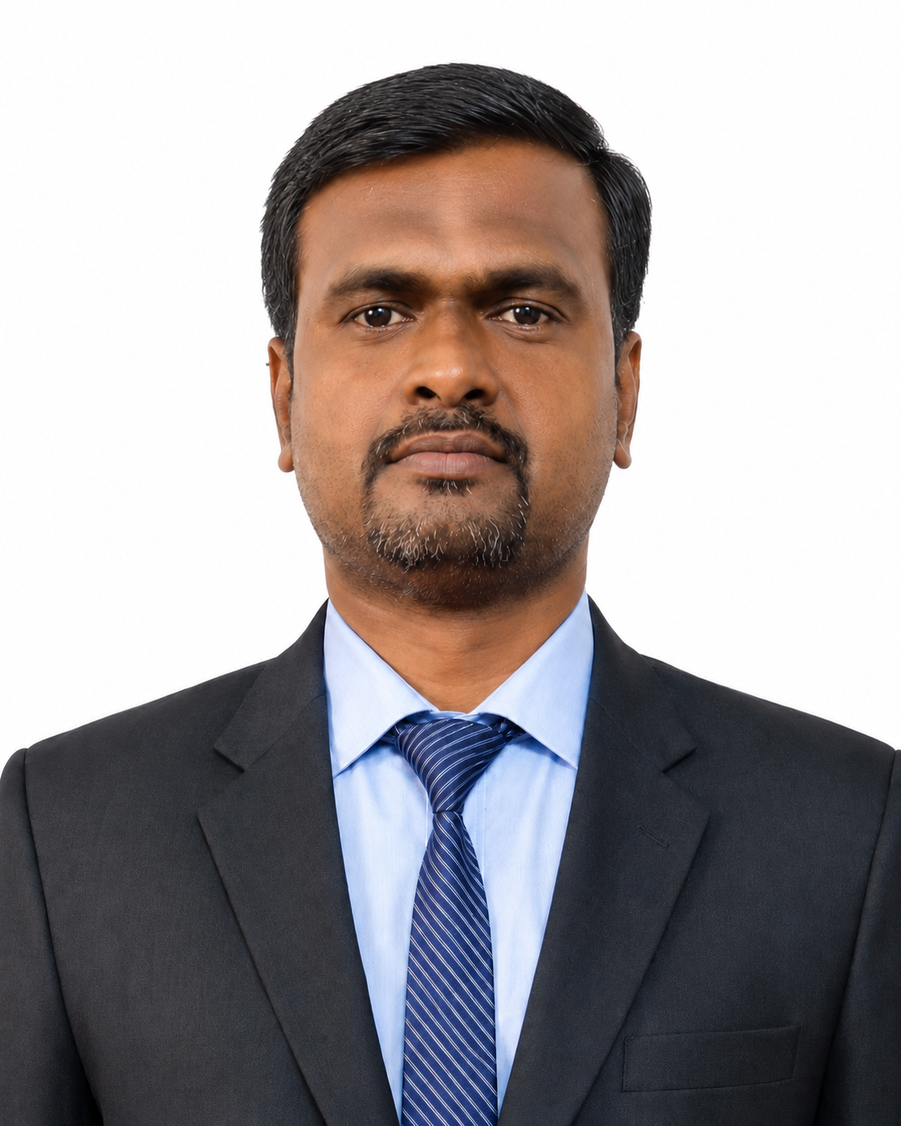
Designation: | Lecturer
Name of Faculty: | Mr. Sadanand Jayshing Jagtap
Date of Birth: | 07/06/1985 | Date of Joining: |  |  |  | 25/06/2026
Qualification with Class/Grade | UG | PG |  |  |  | Ph.D.
Qualification with Class/Grade | First Class | First Class |  |  |  | -------
Area of Specialization: | Design Engineering
Total Experience in Years: | Teaching |  |  | Industry |  |  |  |  |  |  | Research
Total Experience in Years: | 16 |  |  | - |  |  |  |  |  |  | -
Mobile No: | 7768944204 |  |  | E-mail ID: |  |  |  |  |  | sadanandjjagtap@gmail.com
Number of PhD, M. Tech , B. Tech Project Guided | UG: -- |  |  |  |  |  | PG: - |  |  |  |  | Ph.D. : -
Professional Society Memberships | The Institution of Engineers (India) as ASSOCIATE MEMBER with ID AM3117874
Paper Published in Journals | National: - |  |  |  |  |  |  | International: -1
Paper Presented in Conferences | National: 1 |  |  |  |  |  |  | International: 2
Books/Chapters/ Patents / Copy rights Published | Books: - | Chapters:- |  |  |  |  |  | Patents: 01 |  |  |  | Copyrights: -
STTPs, FDPs, Workshops attended | STTPs: 6 |  |  |  | FDPs: 4 |  |  |  |  |  | Workshops: 3
Webinars & Seminars attended | Webinars: 4 |  |  |  |  |  |  |  | Seminars: 2
STTP, FDP,Webinar& Seminar conducted | STTP: - |  | FDP: - |  |  |  |  | Seminar:- |  |  |  | Webinar: -
Resource Person Work Details | -
NPTEL/Swayam/NITTR/MOOC/ Other courses | 02
Awards/Recognitions | -
Consultancy Activities | O -
Google Scholar Link | -
Google Site/Website link | -

Mr. S. J. Jagtap
Name & Signature of Faculty

