FACULTY -BIODATA
Department | Electrical Engineering |  |  |  |  |  |  |  |  |  |  |  | 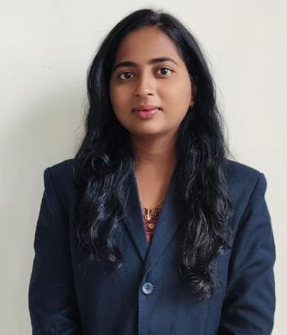
Designation: | Lecturer
Name of Faculty: | Ms. Minal Pandurang Gulik
Date of Birth: | 15 July, 2000 |  |  | Date of Joining: |  |  |  |  |  | 08.06.2025
Qualification with Class/Grade | UG |  |  | PG |  |  |  |  |  | Ph.D.
8.4
(First Class with Distinction)
Area of Specialization:
Total Experience in Years: | Teaching |  |  |  | Industry |  |  |  |  |  |  | Research
 | 0 |  |  |  | 02 |  |  |  |  |  |  | -
Mobile No: | +91 8956318497 |  |  |  | E-mail ID: |  |  |  |  |  | minalgulik_poly@yes.edu.in
Number of , B.Tech Project Guided | UG: |  |  |  |  |  | PG:- |  |  |  |  |  | Ph.D. :-
Professional Society Memberships | -
Paper Published in Journals | National: - |  |  |  |  |  |  | International:
Paper Presented in Conferences | National: - |  |  |  |  |  |  | International: -
Books/Chapters/ Patents / Copy rights Published | Books: - | Chapters:- |  |  |  |  |  | Patents: |  |  |  |  | Copyrights: -
STTPs, FDPs, Workshops attended | STTPs: |  |  |  |  | FDPs: |  |  |  |  |  | Workshops: --
Webinars & Seminars attended | Webinars: |  |  |  |  |  |  |  | Seminars: -
STTP, FDP, Webinar & Seminar conducted | STTP: -- |  | FDP: --03 |  |  |  |  | Seminar: -- |  |  |  |  | Webinar:
Resource Person Work Details | -
NPTEL/Swayam/NITTR/MOOC/ Other courses | -01
Awards/Recognitions | -
Consultancy Activities | O -
Google Scholar Link
Google Site/Website link | -

Ms. Minal Pandurang Gulik
Name & Signature of Faculty

