FACULTY -BIODATA
Department | Civil Polytechnic |  |  |  |  |  |  |  |  |  |  | 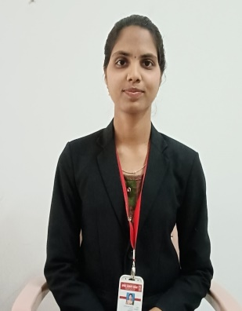
Designation: | Lecturer
Name of Faculty: | Ms. Smita Shivaji Chavan
Date of Birth: | 19/01/2000 | Date of Joining: |  |  |  | 18/02/2022
Qualification with Class/Grade | UG | PG |  |  |  | Ph.D.
 | Distinction | Pursuing
Area of Specialization:
Total Experience in Years: | Teaching |  |  | Industry |  |  |  |  |  |  | Research
 | 03 |  |  | - |  |  |  |  |  |  | -
Mobile No: | 9834418538 |  |  | E-mail ID: |  |  |  |  |  | smitachavan1901@gmail.com
Number of PhD, M.Tech , B.Tech Project Guided | UG: 03 |  |  |  |  |  | PG: |  |  |  |  | Ph.D. :
Professional Society Memberships | Indian Society of Technical Education LM-135967
Paper Published in Journals | National: 03 |  |  |  |  |  |  | International:
Paper Presented in Conferences | National: |  |  |  |  |  |  | International:
Books/Chapters/ Patents / Copy rights Published | Books: - | Chapters: - |  |  |  |  |  | Patents: |  |  |  | Copyrights: -
STTPs, FDPs, Workshops attended | STTPs: |  |  |  | FDPs: 11 |  |  |  |  |  | Workshops: 04
Webinars & Seminars attended | Webinars: 02 |  |  |  |  |  |  |  | Seminars:
STTP, FDP,Webinar& Seminar conducted | STTP: - |  | FDP:- |  |  |  |  | Seminar:- |  |  |  | Webinar: -
Resource Person Work Details
NPTEL/Swayam/NITTR/MOOC/ Other courses
Awards/Recognitions
Consultancy Activities | O
Google Scholar Link
Google Site/Website link

(Ms. S. S. Chavan)
Name & Signature of Faculty

