FACULTY -BIODATA
Department | General Science & Humanities |  |  |  |  |  |  |  |  |  |  | 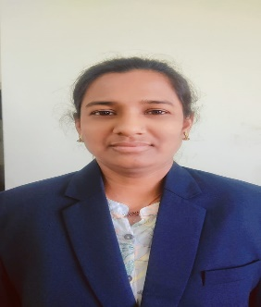
Designation: | Assistant Professor
Qualification: | M. A. B. Ed.
Name of Faculty: | Mrs. Waghmare Swati Amol
Date of Birth: | 29/03/1985 | Date of Joining: |  |  |  | 21/10/2024
Qualification with Class/Grade | UG | PG |  |  |  | Ph.D.
 | First Class | Second Class
Area of Specialization: | English
Total Experience in Years: | Teaching |  |  | Industry |  |  |  |  |  |  | Research
 | 10 |  |  | 00 |  |  |  |  |  |  | 00
Mobile No: | 832980448 |  |  | E-mail ID: |  |  |  |  |  | Swatiwaghmare_poly@yes.edu.in
Number of PhD, M.Tech , B.Tech Project Guided | UG: |  |  |  |  |  | PG: |  |  |  |  | Ph.D.:
Paper Published in Journals | National: |  |  |  |  |  |  | International:
Paper Presented in Conferences | National: |  |  |  |  |  |  | International:
Books/Chapters/ Patents / Copy rights Published | Books: - | Chapters:- |  |  |  |  |  | Patents: |  |  |  | Copyrights: -
STTPs, FDPs, Workshops attended | STTPs: |  |  |  | FDPs: |  |  |  |  |  | Workshops:
Webinars & Seminars attended | Webinars: |  |  |  |  |  |  |  | Seminars:
STTP, FDP, Webinar & Seminar conducted | STTP: |  | FDP: |  |  |  |  | Seminar: |  |  |  | Webinar:
Resource Person Work Details
NPTEL/Swayam/NITTR/MOOC/ Other courses
Consultancy Activities | O
Google Scholar Link
Google Site/Website link

Mrs. Waghmare Swati Amol
Name & Signature of Faculty

