FACULTY -BIODATA
Department | Computer Engineering |  |  |  |  |  |  |  |  |  |  |  |  | 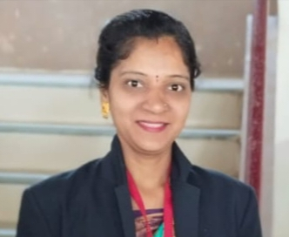
Designation: | Lecturer
Name of Faculty: | Mrs. Yadav Komal Sagar
Date of Birth: | 25/09/1993 |  |  |  | Date of Joining: |  |  | 1/06/2023
Qualification with Class/Grade | UG |  |  |  | PG |  |  | Ph.D.
Diploma .First class
B.E -Distinction
Area of Specialization:
Total Experience in Years: | Teaching |  |  |  |  | Industry |  |  |  |  |  |  | Research
 | Two Year |  |  |  |  | - |  |  |  |  |  |  | -
Mobile No: | 7387248465 |  |  |  |  | E-mail ID: |  |  |  |  | komalpawar259@gmail.com
Number of PhD, M.Tech , B.Tech Project Guided | UG: |  |  | PG: |  |  |  |  |  |  |  | Ph.D. :
Professional Society Memberships | No
Paper Published in Journals | National: 0 |  |  |  |  |  |  |  | International: 0
Paper Presented in Conferences | National: 0 |  |  |  |  |  |  |  | International: 0
Books/Chapters/ Patents / Copy rights Published | Books: -0 | Chapters:- 0 |  |  |  |  |  |  | Patents: 0 |  |  |  |  | Copyrights: -0
STTPs, FDPs, Workshops attended | STTPs: No |  |  |  |  |  | FDPs: No |  |  |  |  |  | Workshops: No
Webinars & Seminars attended | Webinars: Yes |  |  |  |  |  |  |  |  | Seminars: Yes
STTP, FDP, Webinar& Seminar conducted | STP: No |  | FDP: No |  |  |  |  |  | Seminar: No |  |  |  |  | Webinar: No
Resource Person Work Details | -
NPTEL/Swayam/NITTR/MOOC/ Other courses | Computer Network
Awards/Recognitions | No
Consultancy Activities | O No
Google Scholar Link | No
Google Site/Website link | No

Name & Signature of Faculty

