FACULTY -BIODATA
Department | Civil Polytechnic |  |  |  |  |  |  |  |  |  |  | 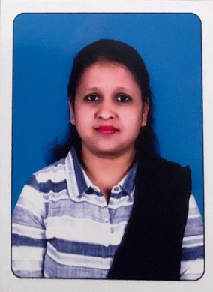
Designation: | Lecturer
Name of Faculty: | Mrs. Khurape Pooja Ravindra
Date of Birth: | 2/6/1991 | Date of Joining: |  |  |  | 10/4/2023
Qualification with Class/Grade | UG | PG |  |  |  | Ph.D.
 |  | M.E
Area of Specialization: | Structure
Total Experience in Years: | Teaching |  |  | Industry |  |  |  |  |  |  | Research
 | 1 |  |  | 4 |  |  |  |  |  |  | -
Mobile No: | 9689977505 |  |  | E-mail ID: |  |  |  |  |  | poojakhurape_poly@yes.edu.in
Number of PhD, M.Tech , B.Tech Project Guided | UG: |  |  |  |  |  | PG: |  |  |  |  | Ph.D. :
Professional Society Memberships
Paper Published in Journals | National: 1 |  |  |  |  |  |  | International:
Paper Presented in Conferences | National: 1 |  |  |  |  |  |  | International: 0
Books/Chapters/ Patents / Copy rights Published | Books: - | Chapters:- |  |  |  |  |  | Patents: |  |  |  | Copyrights: -
STTPs, FDPs, Workshops attended | STTPs: |  |  |  | FDPs: |  |  |  |  |  | Workshops:
Webinars & Seminars attended | Webinars: |  |  |  |  |  |  |  | Seminars:
STTP, FDP,Webinar& Seminar conducted | STTP: |  | FDP: 1 |  |  |  |  | Seminar: |  |  |  | Webinar:
Resource Person Work Details
NPTEL/Swayam/NITTR/MOOC/ Other courses
Awards/Recognitions
Consultancy Activities
Google Scholar Link
Google Site/Website link

Name & Signature of Faculty

