Sr. No. | Event Date | Event
 | 04/09/2025 | Teachers Day
 | 15/09/2025 | Engineer’s Day
 | 15/09/2025 | Felicitation of Toppers

“Teachers Day”

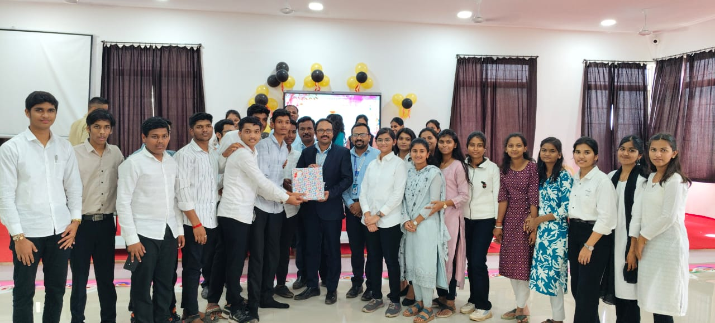 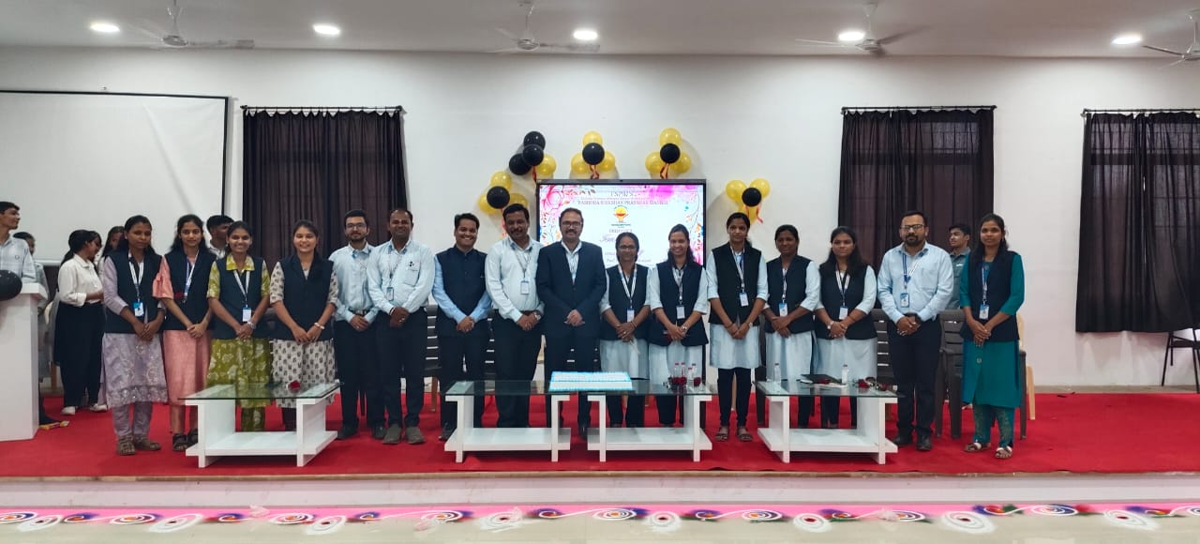"Students Presenting Gift to the Department on Teachers' Day". "Celebrating the heart and soul of education— our wonderful teachers ".

Date: 04/09/2025
Organized by: General Science and Humanities, (Faculty of Polytechnic)
Subject: "Celebrating Wisdom, Dedication, and Heart – Teachers’ Day Special"

Department of General Science and Humanities, Faculty of Polytechnic, YTC, Satara organized a “Teachers Day”, on 04/09/2024 at the Seminar Hall (Faculty of Polytechnic), Satara.
The event was celebrated on the remembrance of birthday of Dr. Sarvepalli Radhakrishnan, a great teacher, scholar, and the second President of India.
The event was honored by the presence of Mr. R. S. Khandekar, Head of Department of First Year, along with the respective HODs of all branches. Students decorated the college campus to show their appreciation for their teachers. The event started by Saraswati Poojan . Students felicitated all the teachers and shared their views on teachers’ day. The celebration commenced with a warm and inspiring speech by Mr. R. S. Khandekar, who highlighted the immense role teachers play in guiding and shaping young minds. He encouraged students to respect and value their educators as pillars of knowledge and wisdom.
Following this, the respective HODs shared their insights and gratitude towards the teaching staff, motivating students to strive for excellence.
A special highlight of the day was the student-led activities dedicated to teachers, including a soulful Sangit Khurchi performance. This musical tribute expressed students’ respect and love for their teachers, creating a warm and joyous atmosphere. The spirit of togetherness was further highlighted when everyone gathered to cut the Teacher’s Day cake, symbolizing the sweetness of the teacher-student bond.
The event was a perfect blend of respect, fun, and heartfelt appreciation, leaving everyone motivated and cherished.

Engineer’s Day

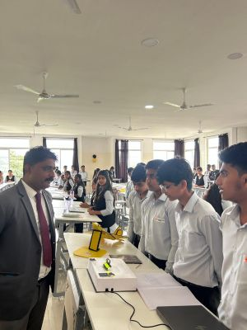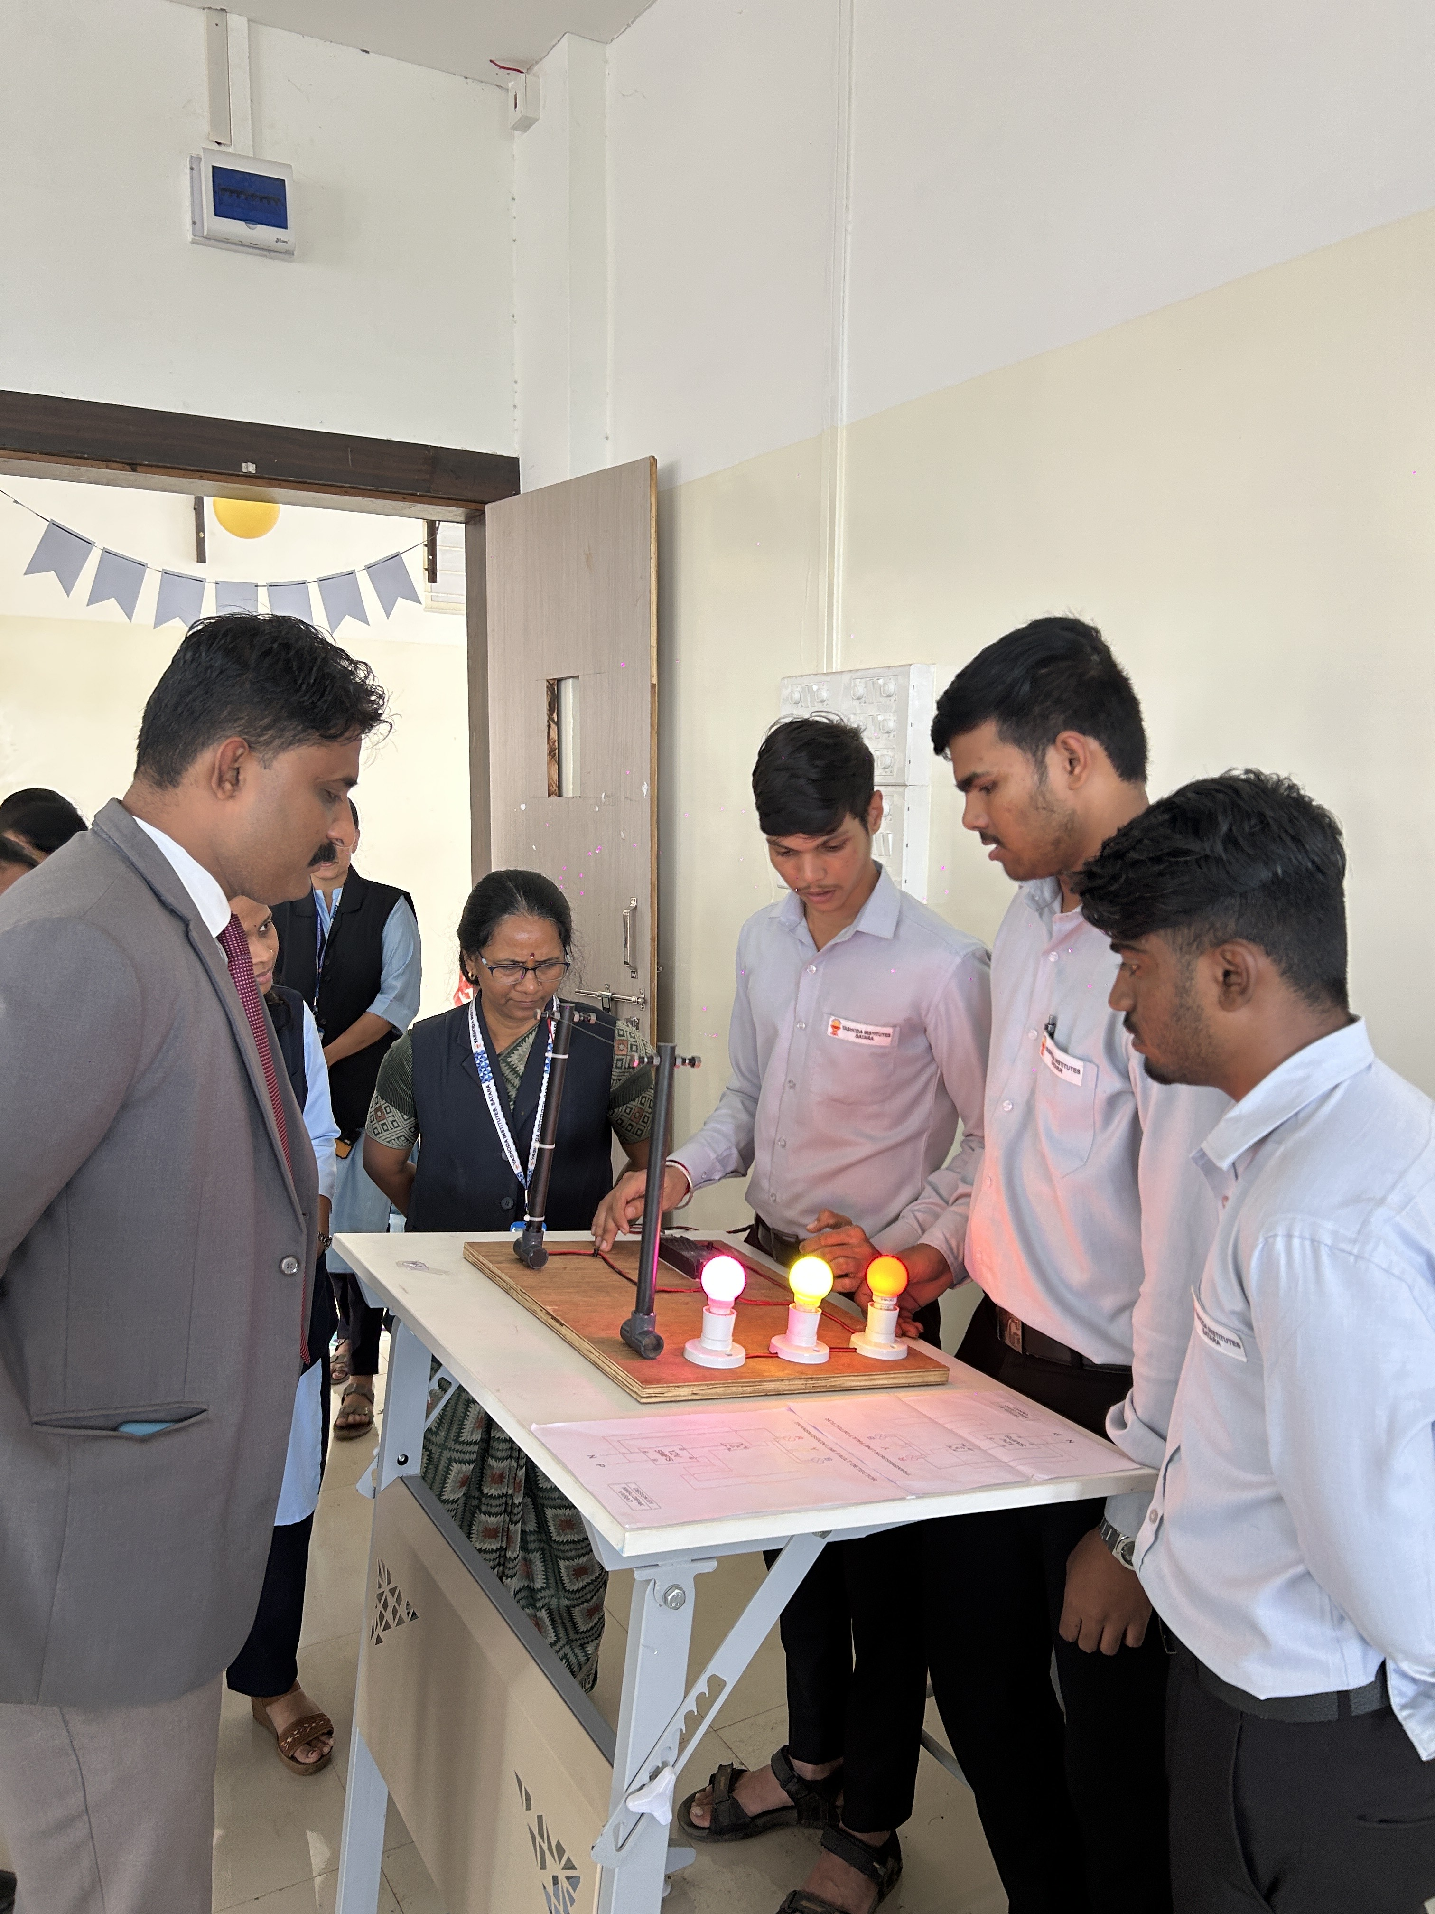
Principal sir’s interaction with students. Principal sir’s interaction with students.

Date: 15/09/2025
Organized by: Department of General Science and Humanities (Faculty of Polytechnic)
Subject: Engineer’s Day Celebration – A Tribute to Innovation and Learning
On the occasion of Engineers Day, the Department of General Science and Humanities, Faculty of Polytechnic, YTC, Satara celebrated “Engineer’s Day” on 15/09/2024. Department honoured the contributions of engineers to national development and recognized the legacy of Sir Mokshagundam Visvesvaraya. The event was graced by our esteemed Principal, Dr. P. P. Gavade, as the Chief Guest, along with Mr. R. S. Khandekar, Head of Department (General Science and Humanities), and event coordinator Ms. P. P. Dhumal. All Heads of Departments and faculty members of first year were present to support and encourage the budding engineers. A series of engaging an educational activities were conducted as part of the celebration, including:
- Elocution Competition
- Technical Idea Presentation
- Poster Presentation
- Working Model Presentation
These activities provided a platform for students to showcase their creativity, technical knowledge, and communication skills. Students participated with great enthusiasm and demonstrated a deep understanding of engineering principles, innovative thinking, and teamwork. Following the competitions, a prize distribution ceremony was held, where Principal Dr. P. P. Gavade congratulated all participants and presented awards to the winners. In his inspiring address, he emphasized the importance of Engineers’ Day and encouraged students to continue striving for excellence in their academic and professional pursuits. The celebration was a grand success, thanks to the efforts of the organizing team led by Ms. P. P. Dhumal and the active involvement of all faculty members. The event not only honored engineering as a profession but also motivated students to explore, innovate, and lead the way forward.

Engineer’s Day

Felicitation of Toppers

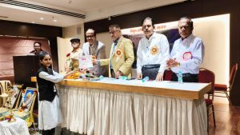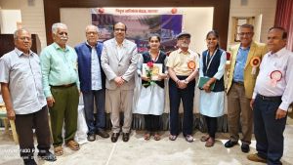
Guest felicitated Student. Guest with student.

Date: 15/09/2025
Organized by: The Retired Engineers Association, Satara
Subject: Dhanashri Mali Felicitated as Topper in First Year at Engineer's Day Celebration

On September 15th, the Retired Engineers Association, Satara, celebrated Engineer's Day with great enthusiasm to honor Bharat Ratna Sir M. Visvesvaraya’s birth anniversary. A key highlight of the event was the felicitation of Dhanashri Mali, who secured the first rank in the first-year diploma examination held in March/April 2025.
Dhanashri Mali’s outstanding academic achievement was recognized with a certificate of appreciation and a cash prize, celebrating her dedication and excellence in engineering studies. Alongside her, other top-ranking students from various engineering branches across Satara city were also honored.
The program, organized under the guidance of Engineer Mr. Kisanrao Moholkar and Engineer Mr. Shivajirao Darekar, emphasized the importance of encouraging young talent in all engineering disciplines. Their efforts to recognize and support academic success were warmly appreciated by students, faculty, and guests.
This event reinforced the commitment of the Satara engineering community to motivate students like Dhanashri Mali, fostering a culture of excellence and inspiring future engineers to achieve their best.

