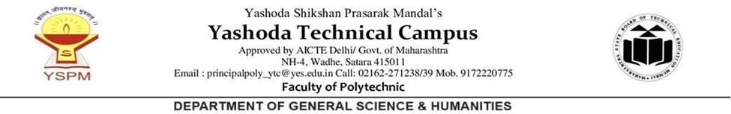
Sr. No. | Event Date | Event
1. | 08-08-2025 to 14-08-2025 | Induction Programme for First-Year Diploma Students at Faculty of Polytechnic

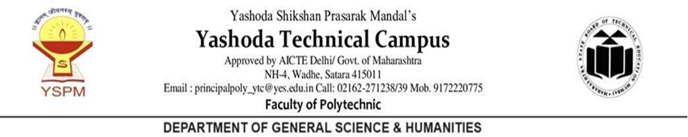
Induction Programme for First-Year Diploma Students at Faculty of Polytechnic

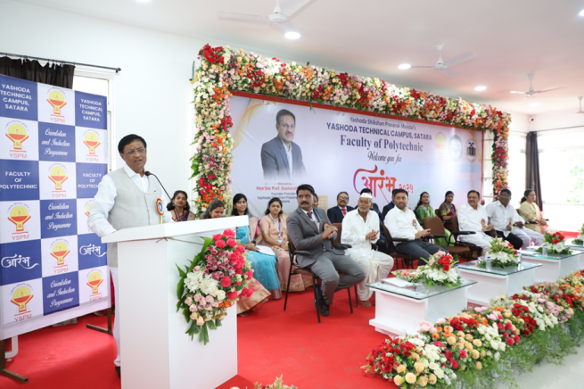
"On the third day, Mr. Yameen Hakim delivered an insightful session on AI trends and job prospects.”
“The induction program began with an inspiring inaugural session graced by Chief Guest -Dr. Yashwant Patane."
"

"Students, staff, and parents attentively participated in the inaugural session on the first day of the induction program."
"Chief Guest Mr. Nilesh Tambe, Police Inspector of Satara Taluka Police Station, inspired students to strive for excellence."

The Faculty of Polytechnic successfully organized a week-long Induction Programme for its first-year diploma students from August 8th to 14th, 2025. The event aimed to welcome new students, introduce them to academic life, and offer insights into career opportunities and industry trends.
The programme kicked off on August 8th with an inspiring inaugural session. Dr. Yashwant Patane, a renowned educationist, was the Chief Guest. Dashrath Sagare, Founder President of Yashoda Shikshan Sanstha, Prof. Ajinkya Sagare, Vice President of Yashoda Shikshan Sanstha, and Principal Dr. P.P. Gavade, along with the entire faculty, warmly welcomed the students. The dignitaries emphasized the importance of discipline, dedication, and continuous learning for academic success.
On the second day, Mr. Tushar Inamdar, CEO of SquareWave, delivered a lecture on emerging technology trends and essential skills for success. Mr. Abhijit Kekare followed with a session on career options for diploma holders, motivating students to explore diverse professional paths.
The third day focused on Artificial Intelligence, with Mr. Yameen Hakim sharing his insights into AI trends and career opportunities in the field, inspiring students to consider AI as a viable career option.
On August 11th, Prof. Pratik Matkar, HOD of Civil Department, conducted a workshop on competitive exam preparation, providing valuable tips and resources. Prof. Ranjit Khandekar, HOD of General Science, delivered a motivational talk on academic excellence and lifelong learning.
The final day began with a grand closing ceremony on August 14th. Chief Guest Mr. Nilesh Tambe, Police Inspector of Satara Taluka Police Station, inspired the students to pursue excellence. Following the ceremony, students visited the Research Science Centre at Varye, gaining valuable insights into research and technology.

