Achievements of General Science Department

The General Science & Humanities department, Yashoda Technical Campus Satara, proudly congratulates our toppers for their outstanding performance in the MSBTE Summer 2025 Examination. Our Four students got 100/100 in Applied Mathematics Subject. Keep striving for excellence. Best wishes from General Science Department.Their hard work, dedication, and sharp problem-solving skills have truly paid off. Our goal is to help every student succeed and build confidence in Mathematics. We encourage students to seek help and take advantage of the additional resources being offered. The administration is committed to monitoring progress and providing continuous support to ensure that students overcome their challenges in mathematics.

Academic Toppers In Applied Mathematics

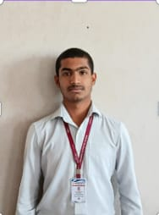
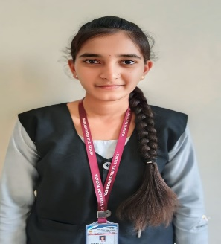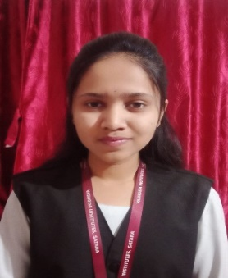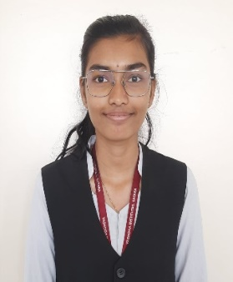
Dhanashri Mali Anushka Gaikwad Aishwarya Nalawade Sufiyan Shaikh
100/100 100/100 100/100 100/100

Achievements of General Science Department

The General Science & Humanities department, Yashoda Technical Campus Satara, proudly congratulates our toppers for their outstanding performance in the MSBTE Summer 2025 Examination. Their dedication and hard work have made us proud. Hard Work and Dedication Pave the Way for Academic Excellence. Keep striving for excellence. Best wishes from Principal Dr. Gavade P. P, HOD. Mr. Khandekar R.S and All Faculty members of General Science Department. Principal congratulated the toppers and praised their dedication. “These students are an inspiration to all. We are proud of their achievements and look forward to their future contributions to society,” he said.
Academic Toppers First Year
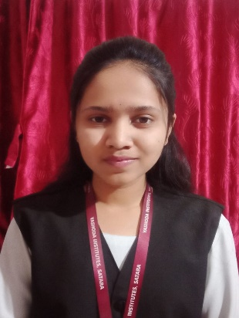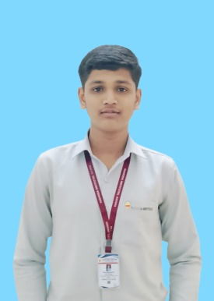
First Rank Second Rank Third Rank
Dhanashri Mali Anushka Gaikwad Aryan Bakale
91.77% 91.29% 88.35%
100/100 100/100
(Applied Mathematics) (Applied Mathematics )

