**A REPORT ON**

**Engineer’s Day program**

**Date**-14 September 2024.

**Venue**- Mechanical seminar hall, YTC.

The Electrical Department, Faculty of Polytechnic, YTC satara, celebrate Engineers day on the occasion of Birth Anniversary of India’s most prominent engineer Dr.Mokshagundam Vishweshvaraya in the remembrance of their remarkable works in engineering field. Our Electrical Dept. celebrates this occasion every year with full of enthusiasm.

The guest lecture arranged was “**Professional Skills for Advanced Design & Embedded Technology**.” We were fortunate to have our chief guest as Associate Manager **Mr. Kishor Podtar, (Embtech** Consumer Electronics & Software, Reasearch Development Team)

The guest for the program were felicitated by Principal sir **Mr. Gavade P. P** (Faculty of Polytechnic)**.**  The program was organized by **Electrical Engineer Students Association** (EESA).

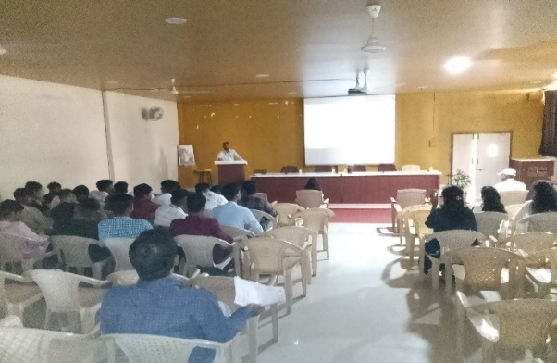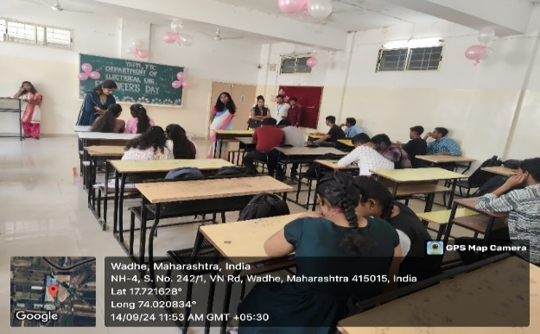Some students shared their opinion of in form of speeches about the Dr.Mokshagumdam Vishweshvaraya. Our chief guest delivered an excellent for the younger generation of Engineers. They pointed out the importance of honesty, Confidence, efforts and leadership skills for the emerging Electrical engineers to raise their career.

|  |  |
| --- | --- |
| Quiz Competition | Guest Lecture of Mr. Kishor Podtar |