**Report on**

**Student Development Program on**

**“LED Lamp Assembling, Testing & Maintenance”**

**“Induction Program for Faculty of Polytechnic”**

The department of Electrical Engineering, Faculty of Polytechnic, YTC, Satara arranged a Two Day’s Student Development Program on **“LED Lamp Assembling, Testing & Maintenance”** for the students of SY & TY class from 27th to 28th September, 2024 under the guidance of Principal **Prof. P. P. Gavade** on the occasion of Yashoda Foundation month**.**

The Assembling and Testing part was delivered by resource person **Dr. M. D. Patil (Associate Professor)**, and maintenance part was delivered by **Mr. R. B. Madake** **(Assistant Professor), ADCET, Ashta.**

The objectives of this SDP were:

* To provide practical knowledge on the assembly, testing, and maintenance of LED lamps.
* To enhance students' skills in working with energy-efficient lighting solutions and understanding LED technology.
* To familiarize students with real-world applications of LED systems in domestic, commercial, and industrial lighting.

This program provided students with valuable practical experience in a growing field. The program equipped them with the skills needed to contribute to energy-efficient lighting solutions, making them more competitive in the job market and more knowledgeable about sustainable technologies.

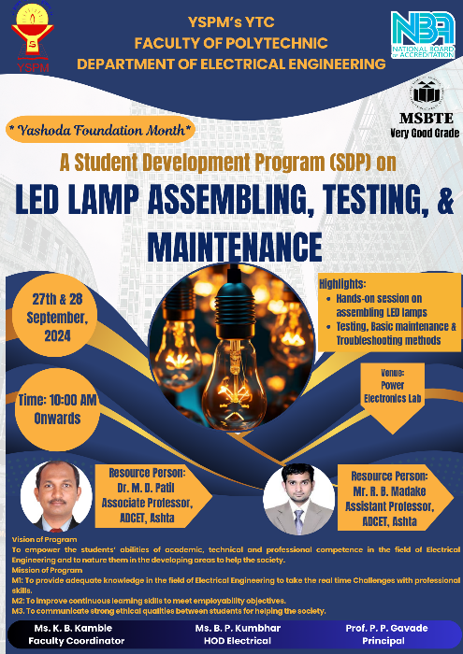

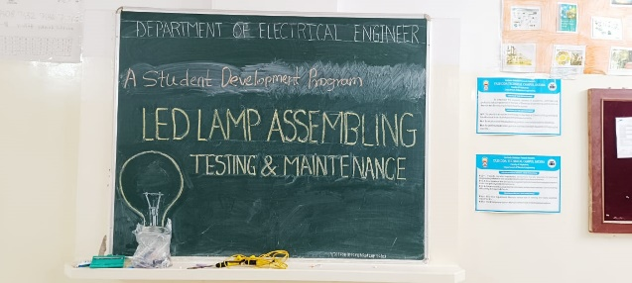

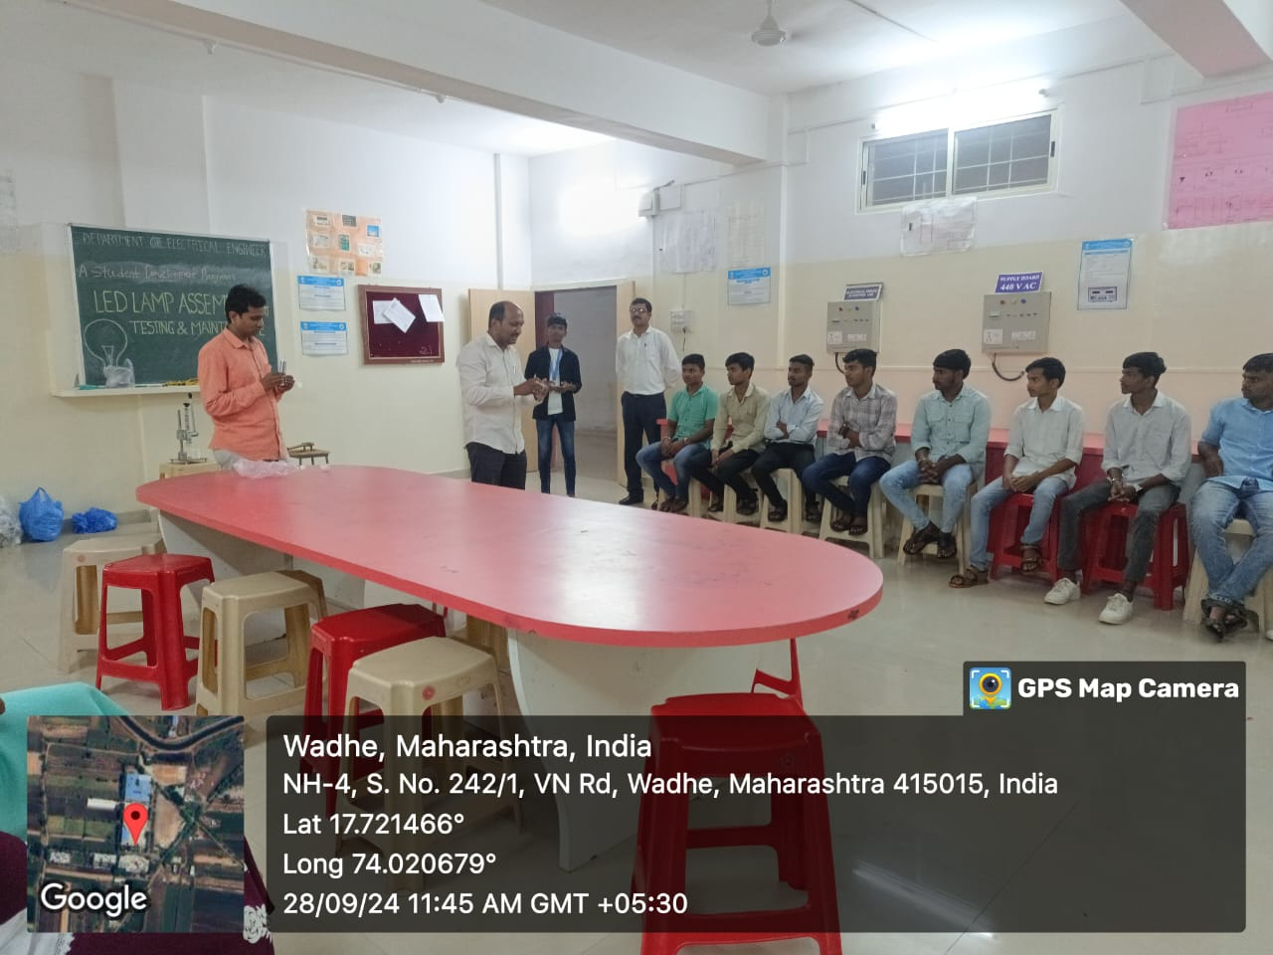 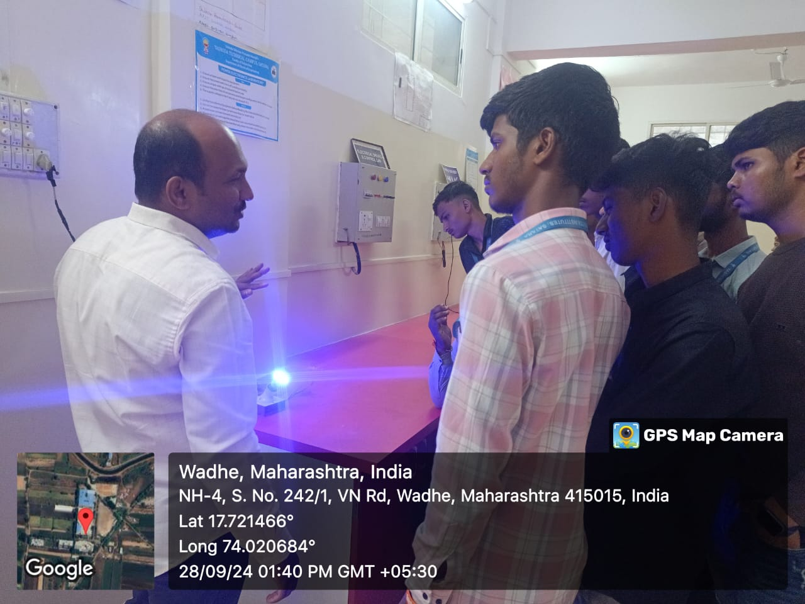

**Dr. M. D. Patil and Mr. R. B. Madake describing and testing assembled lamp**