**A REPORT ON**

**Teacher’s Day Celebration**

The Department of Electrical, Faculty of Polytechnic, YTC satara celebrates Teacher’s Day with great enthusiasm and appreciation on **5th of September 2024**. The program was organized by TY students under guidance of **(EESA).** Students took the initiative to plan and execute the entire event. They coordinated various activities, showcasing their respect and admiration for their teachers. TY students Namrata Mane, Shreya Kadam, Vaishnavi Pangare taught Subjects as EMW, EEM, ECN to SY students. Selected students delivered heartfelt speeches reflecting on the invaluable lessons learned from their teachers.

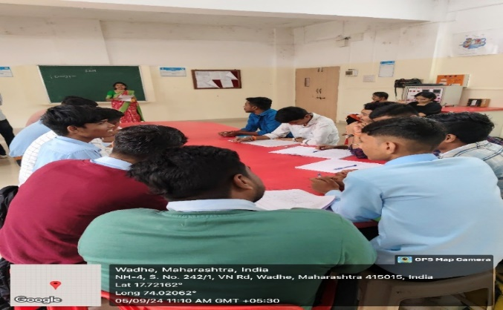 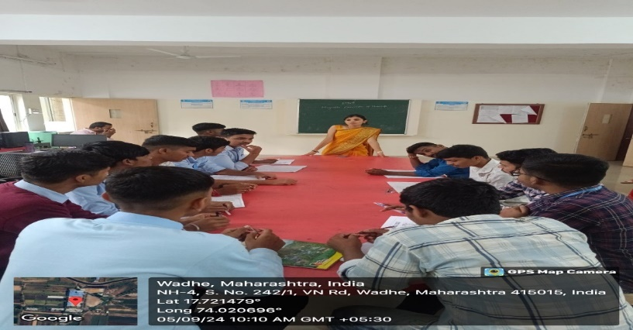

|  |  |
| --- | --- |
| **1.Vaishnavi Pangare teaching ECN subject to SY students** | **2. Namrata Mane teaching EMW subject to SY students** |