**Report on**

**“Induction Program for Faculty of Polytechnic”**

The Department of General Science & Humanity and Department of Electrical Engineering, Faculty of Polytechnic, YTC, Satara, organized a Faculty Induction Program under the guidance of **Hon. Principal Pro. P. P. Gavade**, on **02nd August, 2024** to provide detailed guidance on the National Board of Accreditation (NBA) documentation process. The induction aimed to familiarize faculty members with NBA standards and improve their understanding of the documentation required for the accreditation process. The program was divided into two sessions.

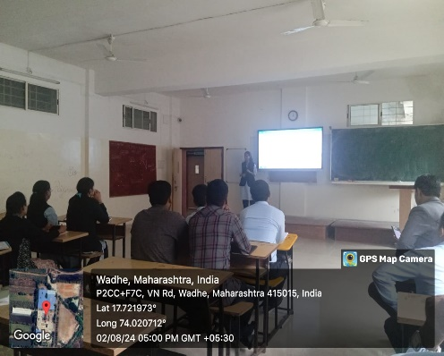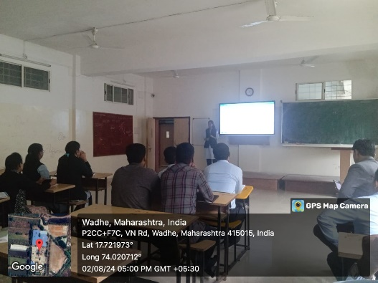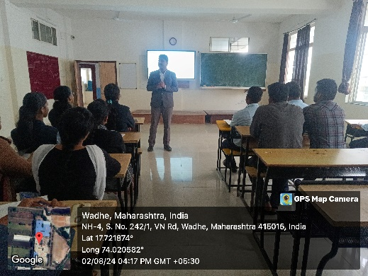The induction program commenced with an inaugural address by **Hon. Principal Pro. P. P. Gavade**, who highlighted the importance of NBA accreditation in improving the quality of education. The first session was led by **Mr. R. S. Khandekar (HOD, Department of General Science & Humanity)**, who provided a comprehensive introduction to the teaching learning process, documentation guidelines regarding course file, program outcomes & program specific outcomes. The second section was delivered by **Ms. B. P. Kumbhar (HOD, Department of Electrical Engineering)**, regarding various assessment processes and their documentation. The program concluded with a vote of thanks delivered by **Mr. P. S. Matkar, (HOD, Department of Civil Engineering)** who expressed gratitude to the experts for their insightful sessions.

**Induction program conducted for Faculty of Polytechnic, YTC, Satara**