**Report on**

**“Skill Development”**

The Department of **Electrical Engineering and Mechanical Engineering** (Faculty of Polytechnic) organized a guest lecture on **August 16, 2024, at 4:00 PM**. This event was conducted under the guidance of Principal **Prof. P. P. Gavade** and TPO Head **Prof. Kharaje sir**. The guest speaker, **Mr. Sachin,** provided valuable insights to the students of **TY** on the topic of "**Skills Development**." He elaborated on various subjects, including future skills and qualifications required for different positions, exploration of various career paths and job roles, and more. The webinar concluded with a vote of thanks delivered by **Prof. R. D. Mohite.**

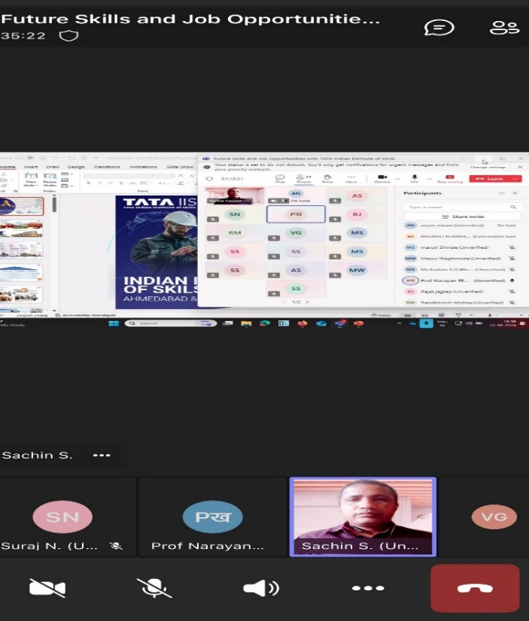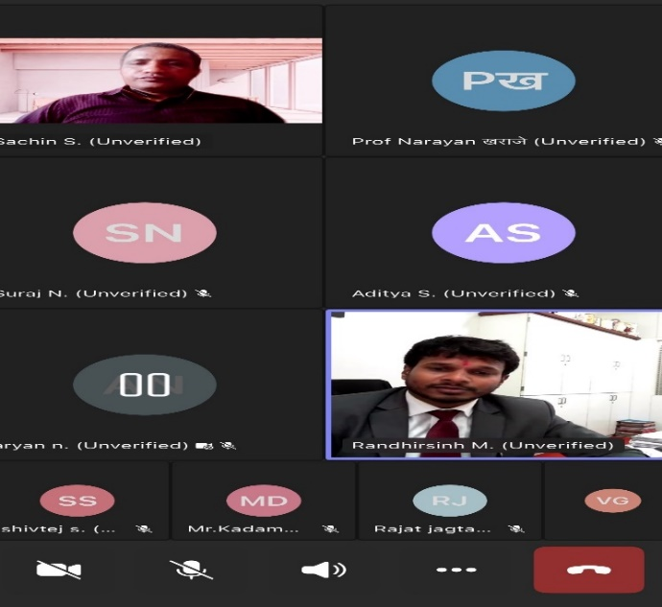

**Mr. Sachin Sir guiding students of Electrical & Mechanical Engineering Department**