|  |  |  |  |  |
| --- | --- | --- | --- | --- |
| **Chapter 1:**  **Introduction to management concepts and managerial skills** | | | | |
| **Teaching Hours: 12** | **Marks Distribution** | | | |
| **Remember =**  **08 M** | **Understanding = 04 M** | **Applying =**  **4 M** | **Total =**  **16 M** |

**Topics and subtopics:**

**1.1** Definitions of management, role and importance of management

**1.2.** Management characteristics and principles, levels of management and their function, Management administration and organization, Relation between management and administration

**1.3** Function of management: Planning, organizing, leading /directing, staffing and controlling

**1.4.** Types of planning and step in planning

**1. 5** Types of organization, step in organizing

**1.6** Function areas of management

**1.7** Manageraial skills

**1.1] Definitions of management, role and importance of management**

Management is the process of using resources to achieve organizational goals.

Management is the process of planning and organizing the resources, operations and workflow of a business to achieve specific goals in the most effective and efficient manner possible.

**Role of management:-**

Manager or supervisor: Responsible for overseeing all activities within a team.

Strategist: Responsible for deciding how to approach tasks and develop a plan to accomplish them.

Communicator: Responsible for distributing information to team members and stakeholders.

Organizer: Responsible for tracking and structuring various tasks, employees, and documents.

Goal setter: Responsible for determining the goals that members will work toward.

**Importance of Management:**

Helps in achieving group goals:

Effective management gives a common direction to individual efforts and guides them towards achieving the overall goals of an organisation.

Increases efficiency:

Efficiency reduces costs and increases productivity in all spheres of an organisation's work.

Creates a dynamic organization:

Management helps its personnel in adapting to change so that the organisation continues to maintain its competitive edge. How well an organisation can respond and adapt to change can mean the difference between its success and failure.

Helps in achieving personal objectives:

Effective management fosters team spirit, cooperation and commitment to achieve the organisational goals as a group, which helps each term member achieve their personal objectives.

**1.2 Management characteristics and principles, levels of management and their function, Management administration and organization, Relation between management and administration**

**Management characteristics**

Goal-oriented: Management is a process that involves planning, organizing, and controlling to achieve objectives

Continuous process: Management is a dynamic function that involves a series of activities

Group activity: Management is a group activity that involves different people with different responsibilities

**Principles of Management -**  are like a guidebook for leaders to run a company well. They help managers make plans, organize tasks, and motivate teams, and, they serve as frameworks for managers to deal with the difficulties of leading people and achieving goals within an organization.

1. **Division of Work**

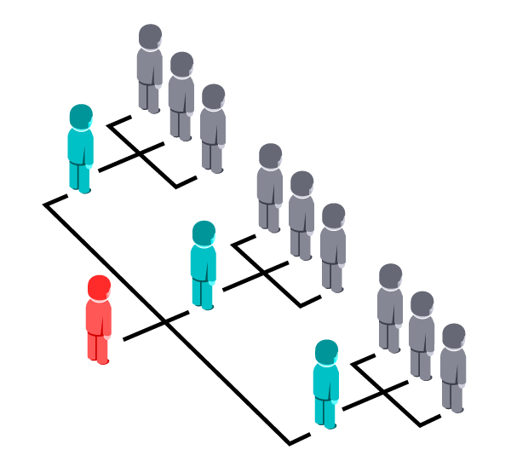

recommended that work of all kinds must be divided and allocated as per competence, qualification, and experience of individuals. According to Fayol, “Division of Work intends to produce more and better work for the same effort.

1. **Authority and Responsibility**

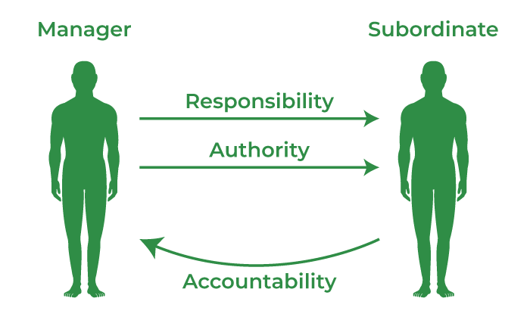

there should be a **proper balance between authority and responsibility**. Authority is the duty, which a subordinate is expected to perform.**Authority and responsibility go hand in hand**.

**3. Discipline**

Discipline refers to obedience to the rules and regulations of the organization. Discipline requires good supervision at all levels of management.



1. **Unity of Command**

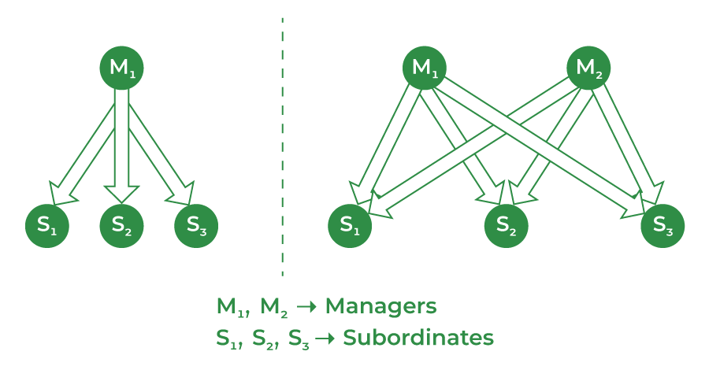

1. **Unity of Direction**



t implies that there should be one head and one person for proof of activities having the same objectives. According to this principle, all the activities should be carried under the direction of one head, and there should be effective coordination in all the activities. This principle ensures unity of action and avoids unnecessary duplication of work.

1. **Subordination of Individual Interest to General Interest**

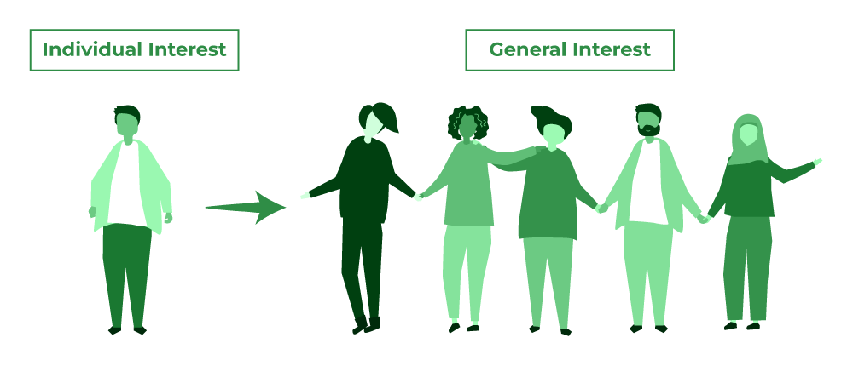

According to this principle, the interest of the organization as a whole must prevail over the interest of the individual. Simply put, the interest of the organization should be placed above the interest of employees.

1. **Remuneration of Employees**



According to this principle, remuneration should be fair and satisfactory to both employees and the organization. This principle leads to harmonious relations in the organization.

1. **Centralization and Decentralization**

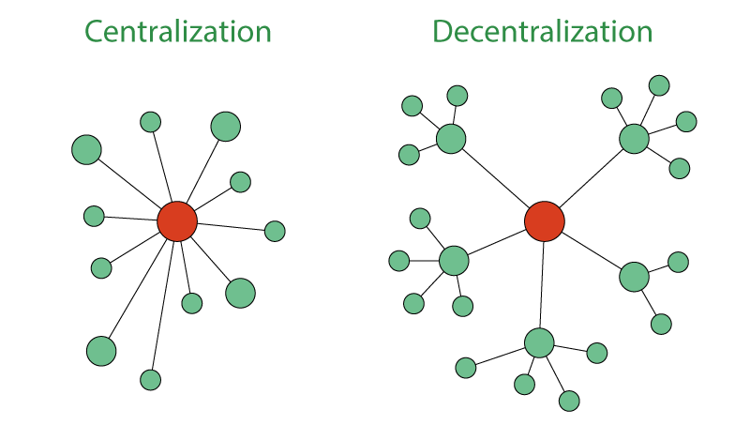

Centralization refers to the concentration of authority at the top level, and decentralization means distribution at all levels of management. According to this principle, there should be a proper balance between centralization and decentralization.

1. **Scalar Chain**

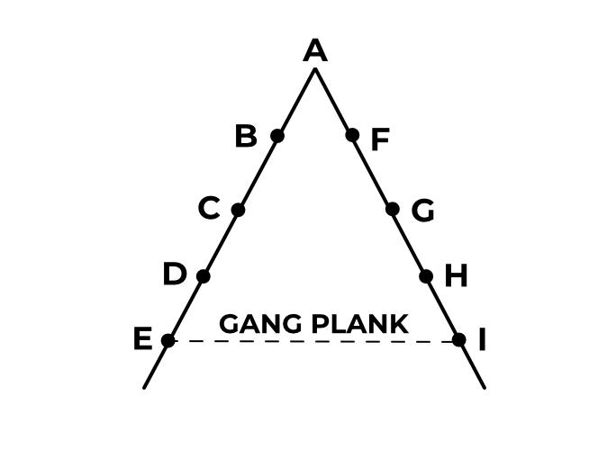

**Levels of management**

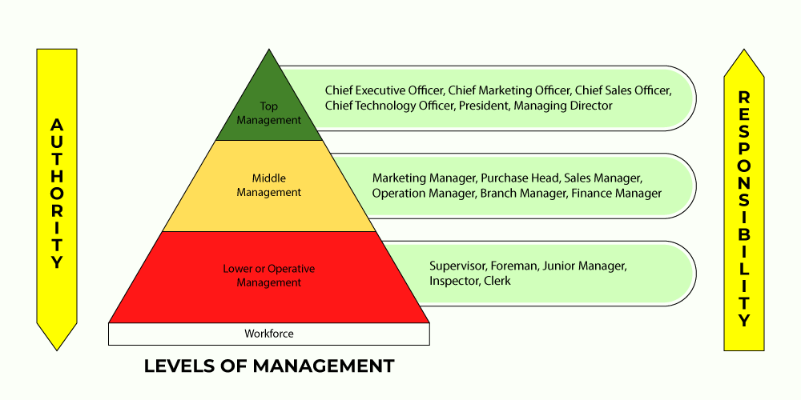

Top-level management: Responsible for overseeing the entire organization

Middle-level management: Responsible for executing plans and acting as a link between top-level and low-level management

Low-level management: Responsible for executing tasks and deliverables

**1.3 Function of management: Planning, organizing, leading /directing, staffing and controlling**

**Management functions**

Planning: Defining the organization's strategy and direction

Staffing: Recruiting and building a team for the organization

Organizing: Putting the organization's structure in place

Directing: Ensuring that employees work efficiently and effectively

Controlling: Overseeing the organization to ensure that objectives are met

**Management administration and organization**

1. **Organization:** An organization refers to a group of people who work together to achieve a common goal. It involves creating a formal structure of roles, responsibilities, and relationships that enable individuals to work together effectively. This structure may include hierarchies, departments, teams, and job descriptions. In an organization, people are allocated specific roles based on their skills and expertise, and work is coordinated through a system of rules and procedures.
2. **Management:** Management refers to the process of directing and controlling the activities of an organization to achieve its goals. It involves making decisions, allocating resources, and supervising employees to work toward the organization’s objectives. Management encompasses all levels of an organization, from top-level executives to front-line supervisors. Managers are responsible for setting goals, developing strategies, and overseeing the organization’s operations.
3. **Administration:** Administration refers to the process of managing the administrative aspects of an organization, such as planning, organizing, staffing, directing, and controlling. It involves ensuring that the organization’s resources are used effectively and efficiently. The administration also develops policies and procedures that guide the organization’s operations. Administrators are responsible for ensuring that the organization complies with regulations and laws and is financially sustainable.

**1.4.** **Types of planning and step in planning**

1. Strategic Planning

Features:

Long-term Focus: Strategic planning deals with the long-term goals and objectives that an organization wants to set out to achieve on its vision and mission.Top Management Involvement: It usually comprises a company’s top executives and decision-makers, who chart the general course and goals that the company shall follow.

2. Tactical Planning

Features:

Shorter-term Focus: Tactical planning focuses on the formulation of short-term to the medium-term goals that help in the attainment of the strategic goals of an organization.

3. Operational Planning

Features:

Detailed and Specific: This type of planning looks at the daily, weekly and the actual activities necessary for organizational effectiveness in the achievement of the specific operations goals.

4. Contingency Planning

Features:

Preparation for Uncertainty: Contingency planning mostly refers to identifying and coming up with a plan to deal with an eventuality that is likely to cause disturbance to the normal proceeding.

5. Financial Planning

Features:

Goal-Oriented: Budgeting involves identification of appropriate goals towards which the finance should be worked in the shortest time and the farthest future.Comprehensive: Topics that fall under personal finance include; budgeting, saving, investment, planning for retirement and managing for risks.

6. Project Planning

Features:

Objective-Oriented: He elaborated that project planning woodland centred on the provision of clear and clear quantifiable goals, milestones or results required in a certain project.

7. Human Resource Planning

Forecasting Needs: HRP stands for Human Resource Planning it is the process of anticipating future human resource requirements with a view of the organizational objectives.

8. Succession Planning

Long-term Perspective: It is a management strategy that is concerned with the search and grooming of talent that has the potential of succeeding in the leadership and important positions.

9.Sales and Marketing Planning

Market Analysis: This fosters understanding of market trends, consumer behaviours or buying patterns and their competitors’ actions in the sales and marketing processes.

10. Business Continuity Planning

Risk Assessment: Outlines potential losses and perils to the running of a business like floods or fires, hacking or interruptions of the source of materials.

**1. 5** **Types of organization, step in organizing**

1] Identifying the Work: he obvious first step in the process of organizing is to identify the work that has to be done by the organization. This is the ground level from which we will begin.

2] Grouping of Work

For the sake of a smooth flow of work and smooth functioning of the organization, similar tasks and activities should be grouped together. Hence we create departments within the company and divisions within each department. Such an organization makes the functioning of the company way more systematic.

3] Establish Hierarchy

The next step in the process of organizing is to establish the reporting relationships for all the individual employees of the company. So a manager establishes the vertical and horizontal relationships of the company.

4] Delegation of Authority

Authority is basically the right an individual has to act according to his wishes and extract obedience from the others. So when a manager is assigned certain duties and responsibilities, he must also be delegated authority to carry out such duties effectively.

5] Coordination

Finally, the manager must ensure that all activities carried out by various employees and groups are well coordinated. Otherwise, it may lead to conflicts between employees, duplication of work and wastage of time and efforts.

**1.6 Function areas of management**

1.. Personnel management 2. Financial Management 3. Marketing Management 4. Production Management 5. Purchase Management 6. Development Management

**1.7 Manageraial skills**

Managerial skills are the knowledge and abilities that allow managers to lead teams and perform their duties. These skills are important across industries, including government agencies, start-ups, and restaurants.

Some examples of managerial skills

Communication: The ability to share information clearly and effectively, both verbally and in writing

Organization: The ability to manage time and workload, and to stay on top of deadlines and events

Problem solving: The ability to identify and solve problems quickly and effectively

Decision making: The ability to identify issues, weigh options, and make clear decisions

Delegation: The ability to share tasks with others to save time and reduce stress

Conflict resolution: The ability to identify the cause of conflicts and come up with solutions that benefit everyone

Motivation: The ability to provide goals and objectives, and to find ways to make work more engaging

Technical skills: The ability to apply specialized knowledge and expertise to perform tasks such as preparing financial statements or analyzing market research